
Christmas Day Menu

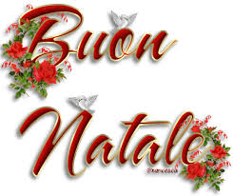
Starters

Gamberoni in Pancetta
King prawns wrapped in pancetta, served with red cabbage, drizzled with balsamic glaze

Prosciutto e Fichi
Parma ham with fresh figs, mascarpone & black pepper mousse

Capesante
Pan-fried king scallops with vanilla and lime sauce, served with baby spinach and pine nuts

Asparagi al Forno
Baked fresh asparagus with mozzarella, tomato & oregano

Zuppa di Zucca
Homemade butternut squash and sweet potato soup, with focaccia croutons

Mains

Tacchino di Natale
Roast turkey with all the trimmings, served with roast potatoes and seasonal vegetables

Filetto in Crosta
Scotch fillet steak topped with mushroom pate crust on a sliced baked potato, spinach & Chianti sauce

Aragosta Gratinata
Fresh whole lobster with onion, English mustard, brandy & cream gratin, served with lobster salad & minted new potatoes

Risotto Porcini
Arborio rice with porcini mushrooms and parmesan crisps

Desserts

Tiramisu
Homemade Baileys tiramisu
Pannacotta
Soft rich vanilla cream with butterscotch sauce
Christmas Pudding
Served with custard and brandy sauce
Profiterols
Served with whipped cream

£60.00

